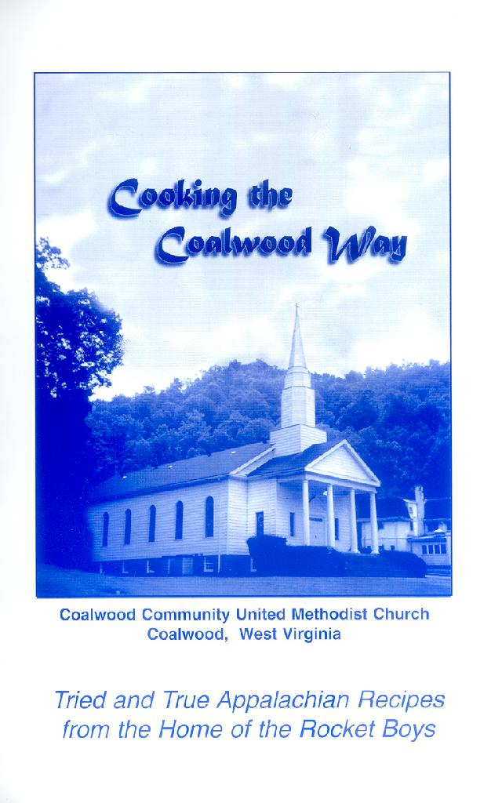
Cooking the Coalwood Way
Tried and True Appalachian Recipes
from the Home of the Rocket Boys

Published by: Coalwood Community United Methodist Church
Coalwood, West Virginia
Spiral-Bound Softcover
150 pages
A poem from the forward of the book:

TRIED AND TRUE,
JUST FOR YOU
Here in beloved Coalwood our Community Church
Has just now completed a huge recipe search.

“Your famous Rocket Boys, what dishes did they eat …?
This … a common question, from the people we meet.

“Share some recipes, Coalwood holds dear,
We love Sonny’s tales, now, recipes let’s hear.”

So we set out to find, those tried and those true,
Recipes we all loved, not some out of the blue.

To get our collection, up the hollows we went,
Over phone and fence-lines, and some e-mails we sent.

Getting our favorites, asking Appalachian folk,
We’ve got examples from all those we spoke.

Now bringing these to you, has been our deepest pleasure.
Cooking the Coalwood Way,
May it be a treasure.

This cookbook contains hundreds of recipes from Coalwood and the hills of Appalachia. In the front of the book is a three-page foreword by Homer Hickam. There are many historic photos of Coalwood sprinkled throughout the book.

Below is a list of some of the recipes that are in the book:

Appetizers & Beverages
Lunch Pail Cheese Spread
Big Creek Sandwich Spread
Ham Rolls
Sterling Drive Inn Submarine
Percolator Punch
Clubhouse Summertime Tea
October Sky Chiller
Soups & Salads
Corn Bread Salad
Miss Riley’s Apricot Salad
Governor Underwood’s Blueberry Jello Salad
Potato Chowder
Keeps Forever Cole Slaw
Vegetables & Side Dishes
Fried Potatoes
Corn Fritters
Grandmother Dantzler’s Corn Pudding
Main Dishes
Sausage Gravy
Chilly Day Chili – Bill Bolt’s Favorite
Little Richard’s Ham Hocks and Greens
Mountain Mama Creamy Macaroni and Cheese
Hamburger Corn Pone Pie
Frog Level Beef Stir Fry
Mediterranean Chicken
Baked Steak
Chicken Pie
Breads and Rolls
Community Church Rolls
Cornmeal Soufflé (Spoon Bread)
Coal Miner’s Favorite Biscuits
Fried Bread
Banana Nut Bread
Oatmeal Muffins
Desserts
Elsie Hickam’s Rocket Boy Banana Pudding
Apple Cobbler Cake
Applesauce Cake
Chocolate Zucchini Bread
Rhubarb Cream Pie
Sock-It-To-Me Cake
Miss Katie’s Raisin Pudding
Apple Pie in a Jar

Cookies & Candy
Lunch Box Moon Pies
Homemade Brownies
Peanut Butter Delight

This & That
Watermelon Preserves
Chow Chow
Blackberry Jam

To order one or more copies of the cookbook, please print out the next page and mail it with a check or money order to the address shown. Thank you!
Order Form

Cooking the Coalwood Way
116 Snake Root Branch Road
Welch, WV 24801-1209

Ship to Name (please print): ______________________________________________

Address (line 1): _________________________________________________________

Address (line 2): _________________________________________________________

City: ______________________________________________________

State: ______________________________________________________

Zip Code: ___________________________________________________

Telephone: ____________________________________________________

Please send me ____________ copy (copies) at $10.00 each. Total: ________________

Add Postage and handling from chart below: ___________

Enclosed is my check of money order for: _____ ________
Checks should be made to:
Coalwood United Methodist Church.

Postage and Handling Chart (books are shipped Media Mail inside the USA):
1 copy: $2.00
2 copies: $2.50
3 copies: $2.50
4 copies: $3.00
5 copies: $3.00
6 copies: $3.50
7 copies: $3.50
8 copies: $4.00
9 copies: $4.50
10 copies: $4.50
11 copies: $5.00
12 copies: $5.00

www.CoalwoodWestVirginia.com

