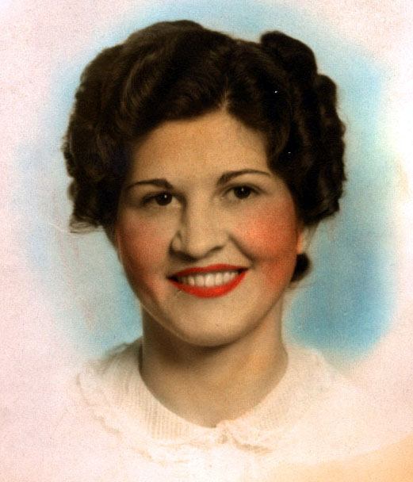
Garden City, SC - Elsie Gardener Hickam, 97, of Garden City, SC, passed away peacefully on October 7, 2009. Until the last, she lived in her house in Garden City, adjacent to Myrtle Beach, South Carolina.

She was born Elsie Gardener Lavender on June 15, 1912 in Atkin (near Gary), McDowell County, West Virginia to James and Minnie Lavender. She lived for many years in Coalwood, West Virginia, then moved to live in Garden City, South Carolina.

She was preceded in death by her husband, Homer Hickam, Sr., who died on Sept. 2, 1989. Until his retirement, Homer was the mine superintendent of Olga Coal Company. Her brothers Kenneth, Joe, Charlie, Victor, and James Kent also preceded her in death.

Elsie was a graduate of Gary High School, class of 1930. She was active in many organizations in Coalwood including the Coalwood Community Church Methodist Women's Circle and the Olga Woman's Club. She also supported the local schools, working tirelessly to raise funds for a variety of student activities. Most of all, she loved whatever her two sons were doing and helped them with advice and counseling throughout her long and splendid life. She was prominently featured in the memoirs written by her second son, Homer, Jr. which included Rocket Boys, The Coalwood Way, Sky of Stone, and We Are Not Afraid. Her character was played by Natalie Canerday in the film October Sky. Last year, she was thrilled when the Northside High School football stadium in Roanoke, Virginia, was named for her son Jim who was the head football coach at Northside for many years.

She is survived by her sister Mary Lavender of Mount Airy, North Carolina, two sons, James Venable Hickam and wife Betty Laphew of Roanoke, Virginia, and Homer (Sonny) Hickam, Jr. and wife Linda Terry of Huntsville, Alabama. She is also survived by a granddaughter, Cheyanne Hickam of Roanoke, and three great grandsons, James David, Michael and Rex Hadley Morgan.

Since Elsie was a lover of all cats, please send memorial donations to www.forgottenfelinesff.petfinder.com or Forgotten Felines, P.O. Box 4506, Huntsville, AL 35815. Memorial services will be private. Please send online condolences to hickam@hiwaay.net.

